5 Senses
Input: World or the Word

Spiritual
Input: Manifestations
Thought Habits

Result of:
Input and
Choice of Thoughts
Prov 4:23

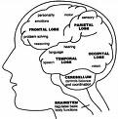
Words,
Actions,
Emotions,
are the results of
thoughts
Rom 8:5-6
Prov 23:7
Change of:
1. Input:
The word and Manifestations

2. Thought Habits

Results In A New Walk
(Manner of Living)
Eph 4

